Slow Fast Learners Summary sheet AY 2025-26

Faculty Name | Subject | Semester | Type | Number of hours
Swapnali Kurhade | Operating Systems | 4 | Remedial Assignment | 3
Jyoti Ramteke | Artificial Intelligence and Soft Computing | 5 | Remedial Assignment | 3
Swapnali Kurhade | Operating systems | 4 | Disk scheduling simulator for fast learners:  Algorithm/ Logic Implementation: 8 – 12 hours  Canvas & Animation Engine :  12-15 hours  UI Design: 10-15 hours  Integration & Results Tracking :  6-10 hours  Testing, Debugging : 5-8 hours  Deployment & Documentation :3-5 hours | ~54 hours
Total |  |  |  | 60 hours

Slow Fast learners Summary sheet AY 2024-25

Faculty Name | Subject | Semester | Type | Number of hours
Swapnali Kurhade | Artificial Intelligence and Machine Learning | 5 | Remedial Assignment  For slow learners | 3
Swapnali Kurhade | Artificial Intelligence and Machine Learning | 5 | Reviewing IEEE papers: 10-15 hours  Setting up libraries: 8-10 hours  Modifying hyperparameters: 10-20 hours  Testing and evaluation: 8-12 hours  Documentation and report: 6 hours | ~52  hours
Swapnali Kurhade | Operating systems | 4 | Assignment for fast learners | 2 hours
Total hours |  |  |  | 57

Bhartiya Vidya Bhavan’s
SARDAR PATEL INSTITUTE OF TECHNOLOGY
(An Empowered Autonomous Institute Affiliated to University of Mumbai)
Munshi Nagar, Andheri (W), Mumbai-400058
DEPARTMENT OF COMPUTER ENGINEERING

Innovative Teaching Learning Practices
Academic Year 2025-26

Sr. No. | Name of the Faculty | Title | Subject | Class | Sem
1 | Jyoti Ramteke | Fun Quiz on AI concepts using Mentimeter | AISC | TE Comps C and D div | V
2 | Reeta Koshy | Flipped Class room - Group discussion of paper and present concept understood.  Outcome - Students participated in discussion fostering active learning and better comprehension. This activity increased student participation and interaction. | Devops | TE Comp AB | V
3 | Swapnali Kurhade | Quiz on Mentimeter, Think-pair-share, open Book Test | AIIA | Final year Comps | VII
4 | Abhijeet Salunke | Used card trick designed to illustrate the applied and practical aspects of the mathematical concept of the Chinese Remainder Theorem.(Course Outcome: Understand the fundamental principles of security cryptography e.g. number theory.) | CNS | TE Comp | V

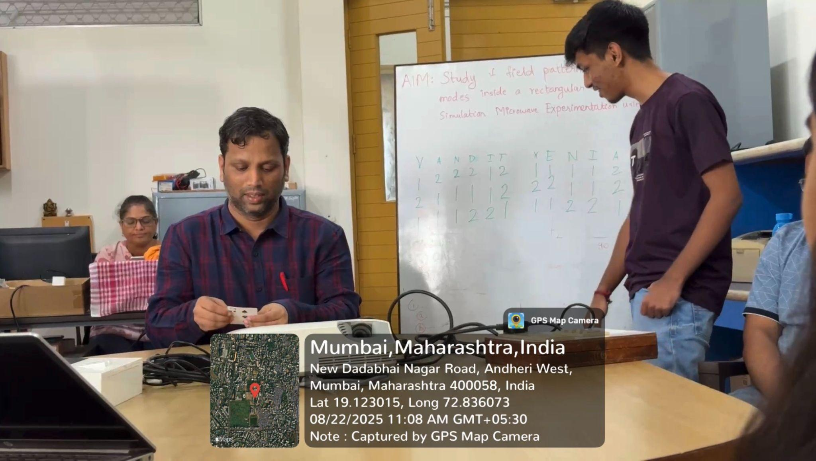

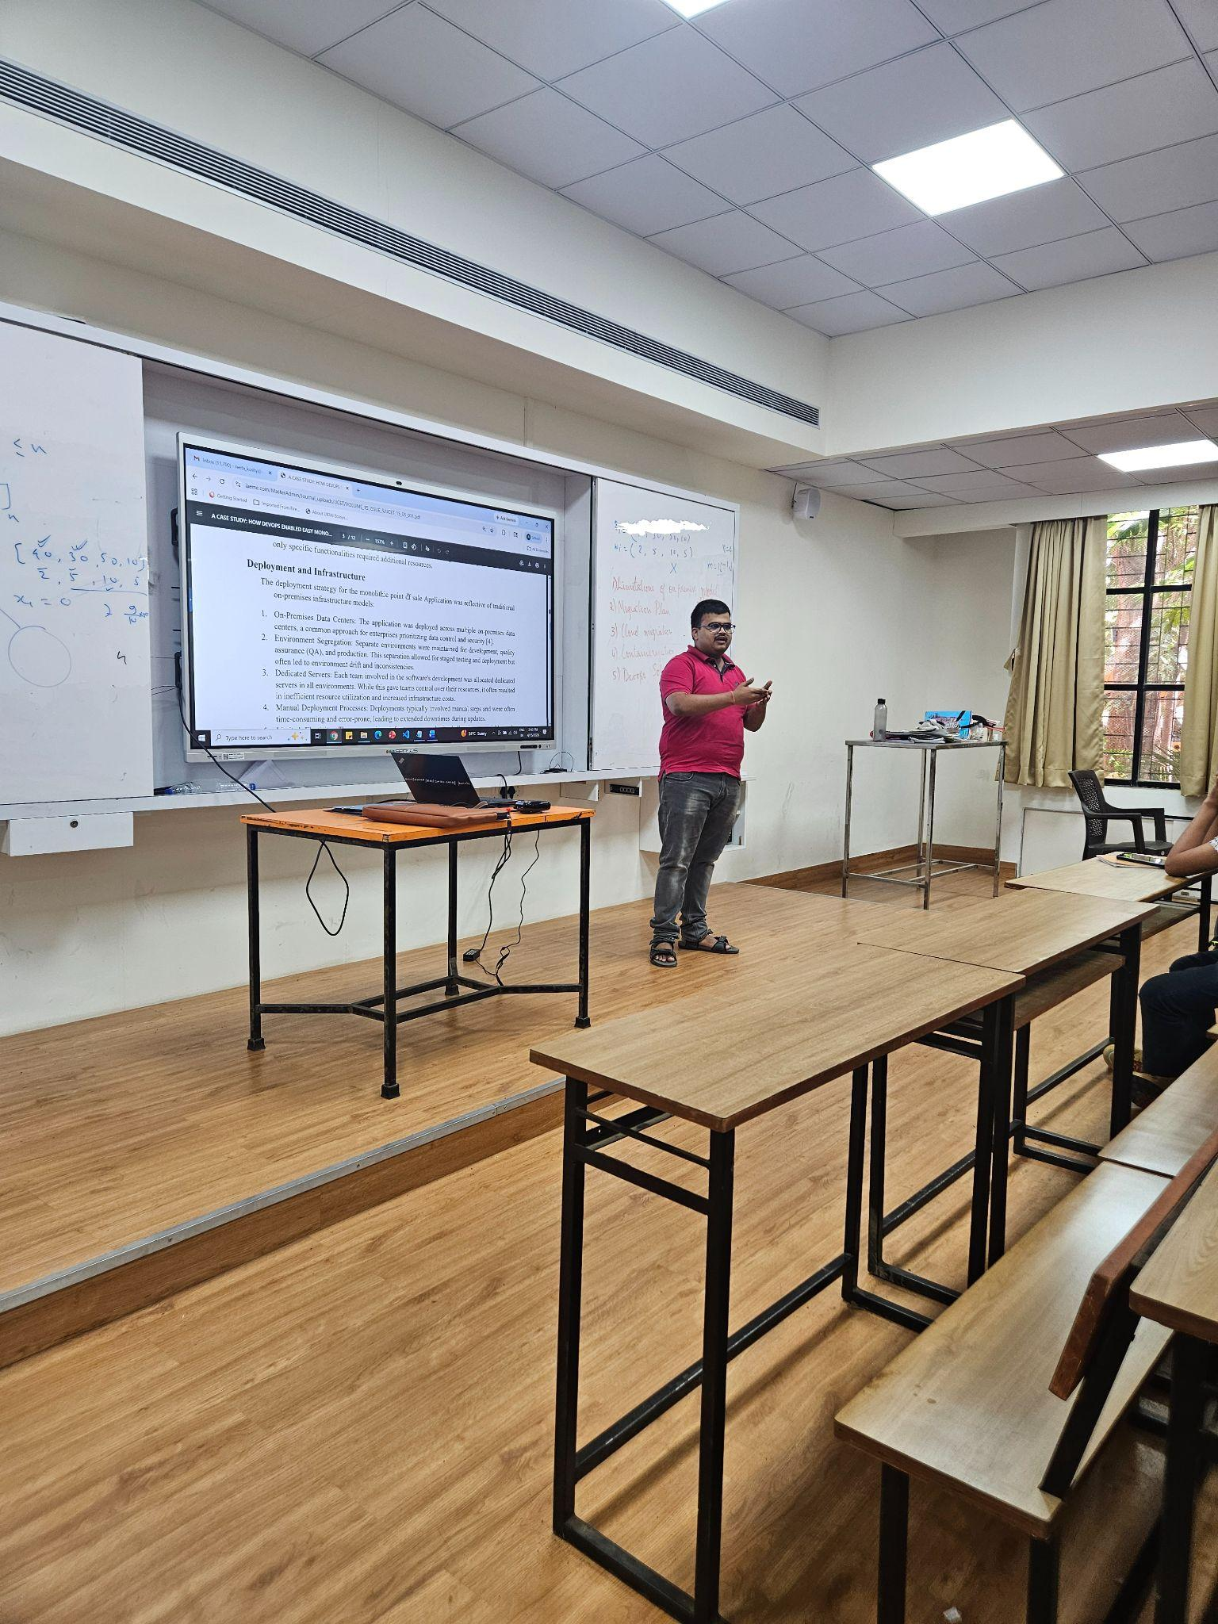

Bhartiya Vidya Bhavan’s
SARDAR PATEL INSTITUTE OF TECHNOLOGY
(An Empowered Autonomous Institute Affiliated to University of Mumbai)
Munshi Nagar, Andheri (W), Mumbai-400058
DEPARTMENT OF COMPUTER ENGINEERING

Innovative Teaching Learning Practices
Academic Year 2024-25

Sr. No. | Name of the Faculty | Title | Subject | Class | Sem
1 | Prof. A. A. Godbole | The 5 Card Trick | Discrete Structures Graph Theory | SE | 3
2 | Prof. Jyoti Ramteke | MENTIMETER QUIZ | DBMS | SE-CSE | 3
3 | Prof. Swapnali Kurhade | Interactive teaching to students during lab hours | Artificial Intelligence & Machine Learning | TE- Div A&B | 5
4 | Prof. Swapnali Kurhade | Interactive Quiz in Mentimeter | Artificial Intelligence & Machine Learning | TE- Div A&B | 5
5 | Dr. Promod Bide | QR code scanning via Android mobile devices | High-Performance Computing (HPC) | B.E- CE | 8
6 | Prof. Swapnali Kurhade | Interactive Quiz in Mentimeter | Operating System | SE- Div C&D | 4

